

Engineering Web Applications Project

Research, report, and present on evaluation methods to be adopted during the whole application lifecycle for promoting WebApp usability.

**Prepared for :** John O’ Brien

**Prepared by :** Robert Gabriel

**Date :** 3 December 2014

**Student Id :** R00102430

Index

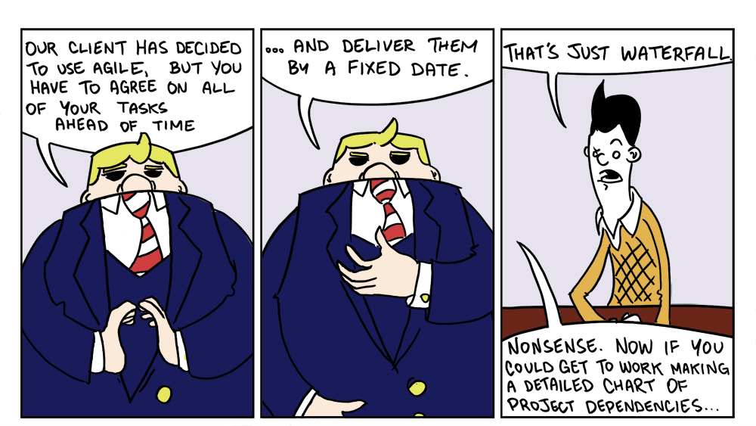

Introduction

Well what is Usability ?

It's when you visit a website or web application and it's difficult to use, it is likely that other visitors and you yourself will leave the website. If the website or landing page fails to clearly state what the website, company does or what users can do on the website, users will leave.If the information is hard to read or access, they will leave. if the content or function of a website cannot be instantly understood, then the user will not stay on the website.

There is no reason for a user to waste their valuable time attempting to figure out an interface. There is are millions of other websites fighting for users visits and business, so the usability of a website is of the utmost importance. When users encounter a difficulty, their first reaction is to leave the page.

Usability is recognized as an important software quality attribute in modern development, earning its place among the other parts such as performance.

There are a several different methods of evaluating usability. Some methods use information and data from users, while others rely on usability experts of the webapp type. There are several different usability evaluation methods for different stages of design and development from the requirements gathering to final design choices and right up until the deployment. When choosing a method, the cost, time constraints, and appropriateness of the testing must all be considered.

**The WebE framework** requires a team who talk and work together on all functions during each stage of the development. Examples our planning, requirements gathering , design, coding, unit testing and adoption testing. This minimizes overall risk and allows the project to adapt to changes quickly.

During the different stages of the WebE framework (agile) process, there are usability methods which can be used to test that the design is working and usable, including:

* Think aloud protocol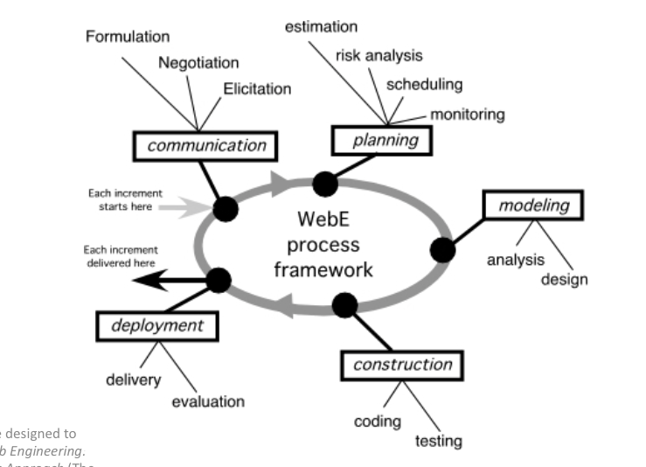
* Focus groups
* Interviews
* Pluralistic walkthrough
* Remote Usability testing

**Note :Planning was left out for room , as reviewing is talked about though**

# Communication (Requirements Engineering)

The first stage in the increments of the WebE process is communication, or in the WebE process framework, customer communication. **Interviews** are a common usability evaluation method during this stage.

One of the best ways to test usability is to start with interviews with the client. The client should be questioned about their experience and their expectations so that the designers and developers can plan around these criteria .

The advantages of interviews are that they gather more information than a questionnaire and go into more detail on the client’s wishes. Unlike questionnaires, interviews provide a personal connection to the client, allowing you to experience their reactions, opinions and insights first hand and overcoming any potential misunderstandings or miscommunications that could result from the use of questionnaires.

There are two types of interview which can be used in this case,

*“Structured interviews have a pre written set of questions and responses. They are sometimes better than questionnaires because thorough response is usually easier and because optional avenues of questioning can be explored which depend on answers to earlier questions. “1*

or

*“Open-ended interviews permit the respondent (interviewee) to provide additional information, ask broad questions without a fixed set of answers, and explore paths of questioning which may occur to the interviewer spontaneously during the interview. An open-ended approach allows for more time to uncover unexpected information, used especially when the exact issues of interest had not been identified yet.”2*

Structured and open-ended interviews can be combined to form a better type of interview . For instance, an interview can begin with preset questions and once the basic questions and information have been covered, and the discussion between the interviewer and the interviewee can open up into other areas.

Other stages that it can used at is design, coding, testing and release of application

|  |  |
| --- | --- |
| **Advantages** | **Disadvantages** |
| Extra detailed information about the project | Can not be performed remotely |
| Less users needed | Does not address the usability issue of efficiency |
| Improve customer relationship and interactions |  |

# Modeling (Prototyping)

The third increment of the web process framework is modeling. In normal software engineering, analysis and design tasks are changed and added to web app development, merged and then melded into the web modeling activity. The intent is to develop fast analysis and design models that define requirements and at the same time represent a web App that will satisfy. During this stage, **focus groups** can be used to evaluate usability.

Focus Groups are a group of users in a webapp or website who are brought together to gather information as input to the design process.

The questions for the users will usually focus on the use of that product. Normally the goal is to understand the users processes into getting task done and gather functional and usability requirements for a webapp or website.

Focus groups offer the opportunity to the users rather than the interviewer to give there opinion on what the important issues are for discussion. There is also the possibility that an unexpected comment from one person will lead to in depth discussions from others in the group . Focus groups are often quicker and faster than interviews and when they involve the stakeholders, they can be valuable for obtaining permission on issues.

However, it is important to not that focus groups can suffer from groupthink problems, where the entire group gets focused on a topic of little importance to project.

|  |  |
| --- | --- |
| **Advantages** | **Disadvantages** |
| Can save money if done before prototyping. | The testing area is not natural to the user and may provide poor results. |
| It creates lot of useful ideas and data from the users using the system | The information collected tends to have low quality in part to the freeform nature of the discussions. |
| Can improve customer relationships over time. |  |

Another method for testing usability during this stage of the web frame is a **pluralistic walkthrough.**

It is where a range of of users ( interface designers, developers, and management) are together to review the design. The walkthrough is started by picking primary tasks for the webapp and stepping through those tasks, identifying usability problems along the way. The purpose of bringing together various different users is that each one brings a different view, expertise, along with a set of goals for the project that allows for more usability problems to be found.

|  |  |
| --- | --- |
| **Advantages** | **Disadvantages** |
| Usability issues are solved faster | Does not address the usability issue of efficiency |
| Greater number of usability problems can be found at one time |  |

# Construction

The fourth increment of the WebE process framework is constriction (Coding/Testing). Once the Web E Framework increments have been made, a few different types of rapid reviews are done to make sure that errors in design (content, architecture, interfaces, navigation etc) are discovered. The WebE process Framework (Agile) development recognizes that testing is not a different phase, but an important included part of software development, along with the coding. During this stage, a usability evaluation method which can used is **Thinking out loud.**

*“*[***Think aloud protocol***](http://en.wikipedia.org/wiki/Think_aloud_protocol) *In a thinking aloud test, you ask test participants to use the system while continuously thinking out loud — that is, simply verbalizing their thoughts as they move through the user interface.”3*

**Think-aloud** is about how well a user performs the required tasks, as talking aloud is quite useful in understanding mistakes that are made, in getting ideas for what the causes of these mistakes might be and in learning how the interface and usability could be improved to avoid those problems. As said before users are asked to speak out loud at what they are looking , thinking, doing and thoughts as they go about getting the task done. This can be done with extreme programming or with group coders as well in pairs.

Think-aloud method has a host of advantages. Most importantly, it lets you discover what the users really think about your design. You hear their mis-understandings, which usually turn into redesign recommendations which in turn leads to changes to the website itself. For example, if a user does not understand some design elements, they will tell you and you then have the opportunity to change them. Even better, you usually learn *why* users guess wrong about some parts of the GUI and why they find others easy to use.

|  |  |
| --- | --- |
| **Advantages** | **Disadvantages** |
| Less expensive | The testing area is not natural to the user |
| Results are close to what is experienced by users |  |

Other stages that it can used at is design, coding, testing and release of application

# Deployment

At this point of the framework process the web app is configured for its environment so that it can be given up to the end users and then an evaluation period commences. Evaluation feedback is presented to the WebE team and is repeated as required in the increment. This includes stress testing and feedback from the beta testers of the stakeholders. During this deployment stage, **Remote Usability testin**[**g**](http://en.wikipedia.org/wiki/Usability_testing#Remote_Usability_Testing) is frequently used for usability evaluation.

During remote usability testing, the development team (usability evaluator) does not directly observe the users while they act and use the web app. Their activity is and may be recorded for viewing later on. In situations where the user and the development team (usability evaluator) are in different countries, remote usability testing is best used over the internet. Remote Usability testin[g](http://en.wikipedia.org/wiki/Usability_testing#Remote_Usability_Testing) is helpful when the end user is specialized, small and based on geolocation. It should be noted that when third party software is used to observe the participants from a distance, there might be a security risk.

|  |  |
| --- | --- |
| **Advantages** | **Disadvantages** |
| Removes the need for a testing environment and the effect of a testing environment on participants | Security could be compromised if testing sensitive or intellectual property. |
| Allows for testing for diverse groups of users. | No view of the user’s body language which shows some of the cues to their reactions to what is being tested. |
| Is less expensive than a traditional in-person testing |  |

Other stages that it can used at is design, coding, testing and release of application

To Finish its important and what I took away from from this report. Is it is to design for the user and not the purpose.

References

<http://en.wikipedia.org/wiki/Agile_software_development>

Date Accessed : 7/11/2014

<http://en.wikipedia.org/wiki/Usability>

Date Accessed : 10/11/2014

<http://www.usabilityfirst.com/glossary/think-aloud-protocol/>

Date Accessed : 11/11/2014 Reference code 3

<http://johnnyholland.org/2010/06/pros-and-cons-of-remote-usability-testing/>

Date Accessed : 21/11/2014

http://www.usability.gov/how-to-and-tools/methods/remote-testing.html

Date Accessed : 22/11/2014

<http://www.usabilityfirst.com/glossary/interview/>

Date Accessed 21/11/2014 Reference code 1 and 2